IMMEDIATE RELEASE - THURSDAY 21 SEPTEMBER 2023
Hamilton Gallery Trust Announces Mr Allan Myers as New Trustee

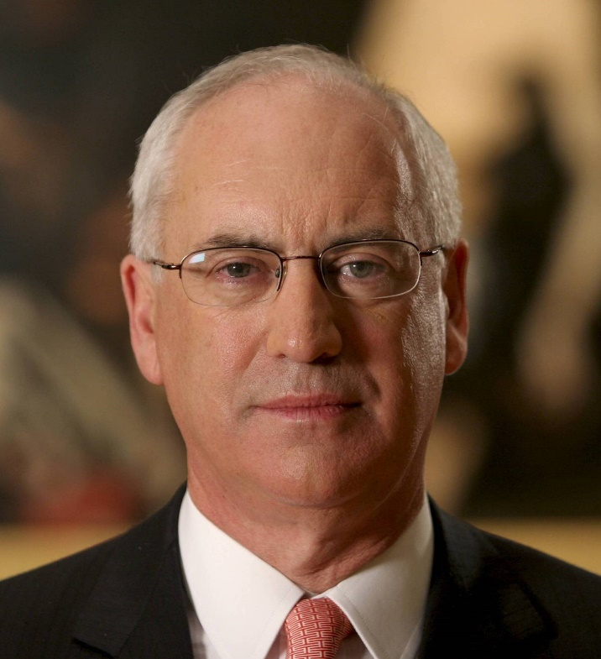

One of Australia's most important arts experts and supporters, Mr Allan Myers AC KC will become a new trustee of the Hamilton Gallery Trust.

Mr Myers will replace Dr Sue Robertson who has announced her departure from the trust after over two decades of service. Dr Robertson has been a committed trustee for an incredible 22 years and has given countless hours of expert skill for the betterment of the Gallery and community.
Gallery Director, Joshua White said Dr Robertson has been a steady guide and inspiration to work with, which has been greatly beneficial to the local community.

"Dr Robertson has been one of the driving forces behind the trust’s success for over two decades,” said Mr White. “Her dedication and generosity have been truly remarkable, and she leaves behind a legacy that will continue to make an impact."

Mr Myers will be the twelfth trustee since the Gallery opened sixty years ago. He will be formally appointed to the position at the trust’s annual general meeting in December.

Mr White said that it would be an honour to work with Mr Myers, who brings an extraordinary breadth of experience and skill, alongside a deep connection to the Australian art world.

“Mr Myers has been a leader within Australian arts for many decades and we are extremely fortunate to have him as a trustee. As the former President of the Council of Trustees of the National Gallery of Victoria for 10 years and the Chair of the National Gallery of Australia for over 6 years, we are thrilled to have an individual with his knowledge and expertise.”

Other accomplishments include being chair for over 6 years of the Museums and Art Galleries Board of the Northern Territory (MAGNT), where he successfully ushered in a new era for the institution to be recognised as a statutory authority, ensuring MAGNT’s maximum impact and longevity to culture and the community. He was the founding chair of the Grattan Institute for 7 years, served on the board of the Felton Bequest and the Ian Potter Foundation and most recently, he was the Chancellor of the University of Melbourne for 6 years.

Current trustee, Mr Gordon Dickinson stated that “Mr Myers is a longstanding champion of our region, particularly in the realm of the arts. His profound understanding and relationship to the Australian art world has played an instrumental role in shaping the cultural landscape of our nation. We admire his work and look forward to collaborating closely with him to enhance the cultural lives of our community.”
The Hamilton Gallery Trust is one of the oldest and most successful trusts in Australia, contributing over 600 works of art to the Gallery’s internationally renowned collection for over six decades.

--- Ends ---

Please contact us for further information, quotes or images.

MEDIA ENQUIRIES:
Stacey Barnes | Marketing Coordinator – marketing@hamiltongallery.org | 0429 499 373

